**PATUAKHALI SCIENCE AND TECHNOLOGY UNIVERSITY**



**COURSE CODE: CCE-211**

**Course Title: Data Communication and Networking**

**SUBMITTED TO:**

### **Prof. Dr. Md Samsuzzaman**

### **Department of Computer and Communication Engineering**

**Faculty of Computer Science and Engineering**

**SUBMITTED BY:**

**NAYEMA FERDOUSHI**

ID: **2102026**

Registration No: **10153**

**Faculty of Computer Science and Engineering**

Assignment Topic: Chapter Three (Physical Layer)

Date of Submission: 04-05-2024

**Q3-1.** What is the relationship between period and frequency?

Answer: Period, T = 1/ Frequency, f

**Q3-2.** What does the amplitude of a signal measure? What does the frequency of a signal measure? What does the phase of a signal measure?

Answer:   
The amplitude of a signal measures its strength or intensity. It represents the maximum displacement of the signal from its baseline.

The frequency of a signal measures how many complete cycles of the waveform occur in a given unit of time (Hz).

The phase of a signal measures the relative timing of the waveform compared to a reference point. (radian or degree)

**Q3-3.** How can a composite signal be decomposed into its individual frequencies?

Answer:

If the composite signal is periodic, the decomposition gives a series of signals with discrete frequency. If the composite signal is non-periodic, the decomposition gives a combination of sine waves with continuous frequency.

**Q3-4.** Name three types of transmission impairment.

Answer:

1. Attenuation
2. Distortion
3. Noise

**Q3-5.** Distinguish between baseband transmission and broadband transmission.

Answer:

Baseband: digital to digital

Broadband: digital to analog

**Q3-6.** Distinguish between a low-pass channel and a band-pass channel.

Answer:

Low-pass channel: a bandwidth that starts from zero.

Band-pass channel: doesn’t start from zero.

**Q3-7.** What does the Nyquist theorem have to do with communications?

Answer:

Nyquist theorem ensures accurate signal reconstruction in communications by setting minimum sampling rates.

**Q3-8.** What does the Shannon capacity have to do with communications?

Answer:

The Shannon capacity determines the maximum data rate achievable over a communication channel, shaping the design of efficient communication systems.

**Q3-9.** Why do optical signals used in fiber optic cables have a very short wave length?

Answer:

To minimize signal attenuation and maximize data transmission capacity.

**Q3-10.** Can we say whether a signal is periodic or nonperiodic by just looking at its frequency domain plot? How?

Answer: Yes.

Non-periodic: a continuous frequency distribution

Periodic: exhibit discrete spectral lines at harmonics of a fundamental frequency.

**Q3-11.** Is the frequency domain plot of a voice signal discrete or continuous?

Answer: Continuous.

**Q3-12.** Is the frequency domain plot of an alarm system discrete or continuous?

Answer: Discrete.

**Q3-13.** We send a voice signal from a microphone to a recorder. Is this baseband or broadband transmission?

Answer: Baseband.

**Q3-14.** We send a digital signal from one station on a LAN to another station. Is this baseband or broadband transmission?

Answer: Broadband.

**Q3-15.** We modulate several voice signals and send them through the air. Is this base band or broadband transmission?

Answer: Broadband.

**P3-1.** Given the frequencies listed below, calculate the corresponding periods.  **a.** 24 Hz **b.** 8 MHz **c.** 140 KHz

Answer:

a. For 24 Hz: 𝑇=1/24=0.0417 seconds *T*=241​=0.0417seconds

b. For 8 MHz: 𝑇=1/8×10^6=1.25×10^−7 seconds *T*=8×1061​=1.25×10−7seconds

c. For 140 KHz: 𝑇=1/140×10^3=7.14×10^−6 seconds *T*=140×1031​=7.14×10−6seconds

Top of Form

**P3-2.** Given the following periods, calculate the corresponding frequencies.  **a.** 5 s **b.** 12 μs **c.** 220 ns

Answer:

a. For 5 s: 𝑓=1/5=0.2 Hz *f*=51​=0.2Hz

b. For 12 μs: 𝑓=1/12×10−6=83.3 MHz *f*=12×10^−61​=83.3MHz

c. For 220 ns: 𝑓=1/220×10−9=4.55 GHz *f*=220×10^−91​=4.55GHzTop of Form

**P3-3.** What is the phase shift for the following?

**a.** A sine wave with the maximum amplitude at time zero

**b.** A sine wave with maximum amplitude after 1/4 cycle

**c.** A sine wave with zero amplitude after 3/4 cycle and increasing

Answer:

a. 0 degree

b.90 degree

c. 270 degree

**P3-4.** What is the bandwidth of a signal that can be decomposed into five sine waves with frequencies at 0, 20, 50, 100, and 200 Hz? All peak amplitudes are the same. Draw the bandwidth.

Answer:

The bandwidth = high frequency -low frequency = 200 Hz – 0 Hz = 200 Hz

**~~I can’t draw the bandwidth :)~~**

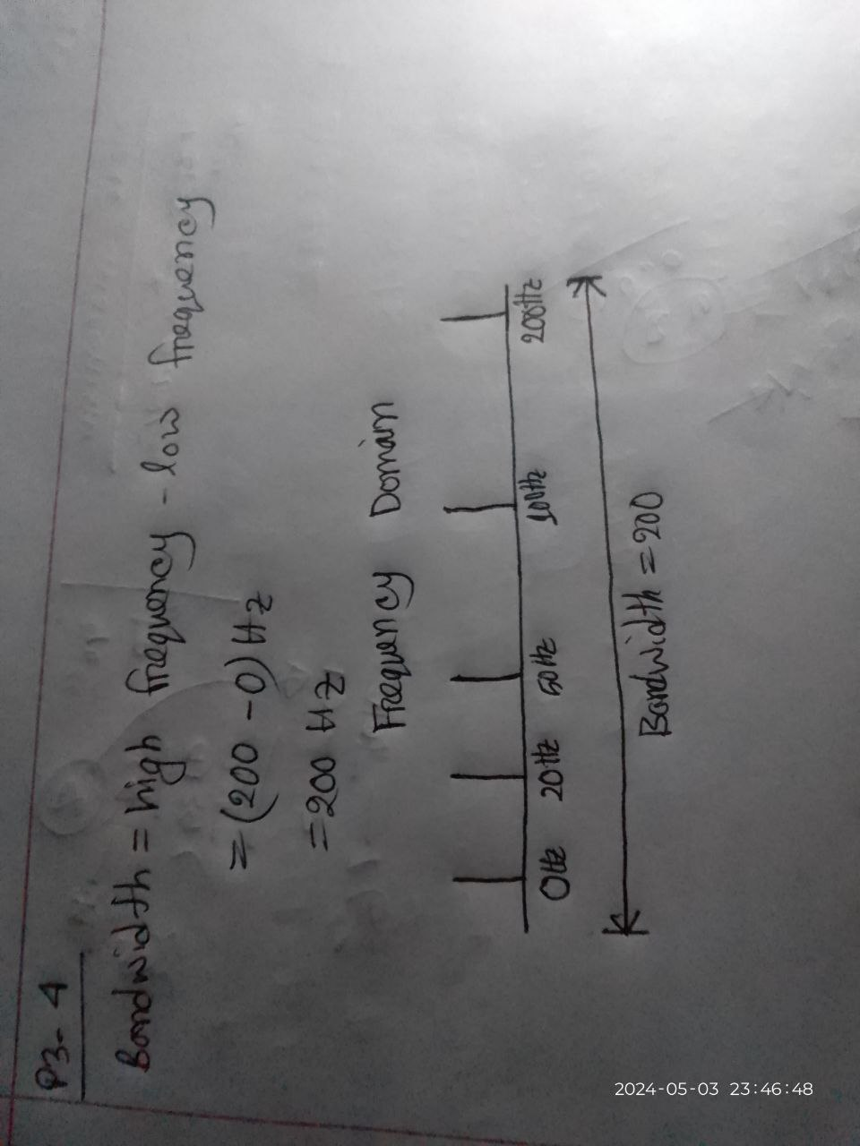

**P3-5.** A periodic composite signal with a bandwidth of 2000 Hz is composed of two sine waves. The first one has a frequency of 100 Hz with a maximum amplitude of 20 V; the second one has a maximum amplitude of 5 V. Draw the bandwidth. 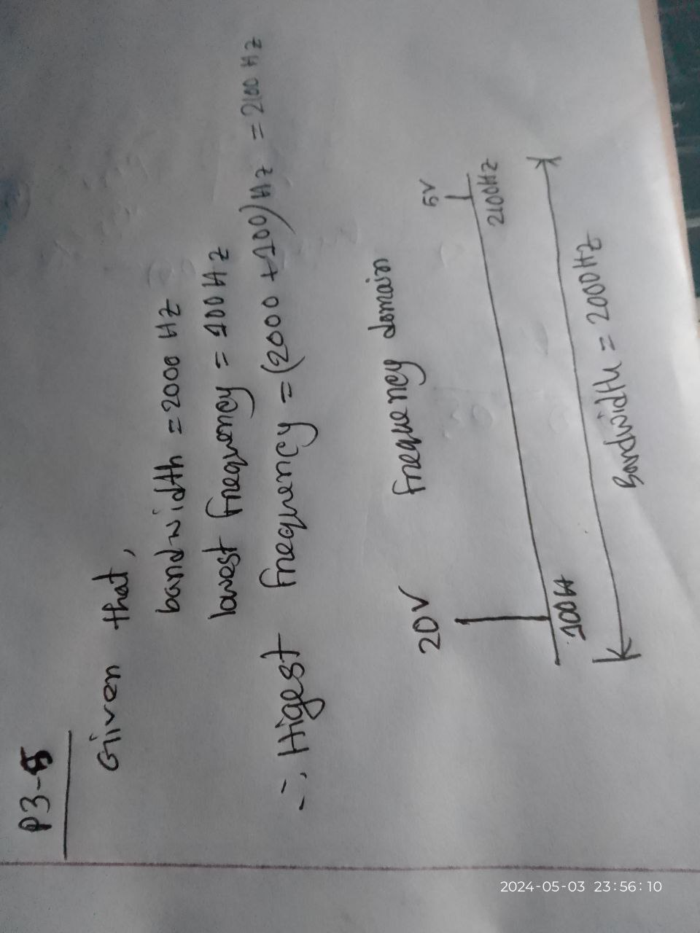

**P3-6.** Which signal has a wider bandwidth, a sine wave with a frequency of 100 Hz or a sine wave with a frequency of 200 Hz?

Answer: The bandwidth of both signals are the same.

**P3-7.** What is the bit rate for each of the following signals?

**a.** A signal in which 1 bit lasts 0.001 s

**b.** A signal in which 1 bit lasts 2 ms

**c.** A signal in which 10 bits last 20 μs

Answer: bit rate = 1/ ( bit duration)

a. 1000bps

b.500bps

c.500,000bps

**P3-8.** A device is sending out data at the rate of 1000 bps.

**a.** How long does it take to send out 10 bits?

**b.** How long does it take to send out a single character (8 bits)?

**c.** How long does it take to send a file of 100,000 characters?

Answer: bit duration = bit / bit rate

1. 10/1000 = 0.01s
2. 8/1000 = 0.008s
3. (100,000 x 8 )/ 1000 = 800s

**P3-9.** What is the bit rate for the signal in Figure 3.35?

**Answer:**

There are 8bits in 16ns.

So, bit rate = 8/ 16 x 10^-9 = 500Mbps.

**P3-10.** What is the frequency of the signal in Figure 3.36?

**Answer:** Frequency: 8/ (4 ${10}^{-6}$* )=2 ${10}^{6}$* Hz

**P3-11.** What is the bandwidth of the composite signal shown in Figure 3.37?

**Answer:**

Bandwidth: 5*5=25 Hz

**P3-12.** A periodic composite signal contains frequencies from 10 to 30 KHz, each with an amplitude of 10 V. Draw the frequency spectrum. 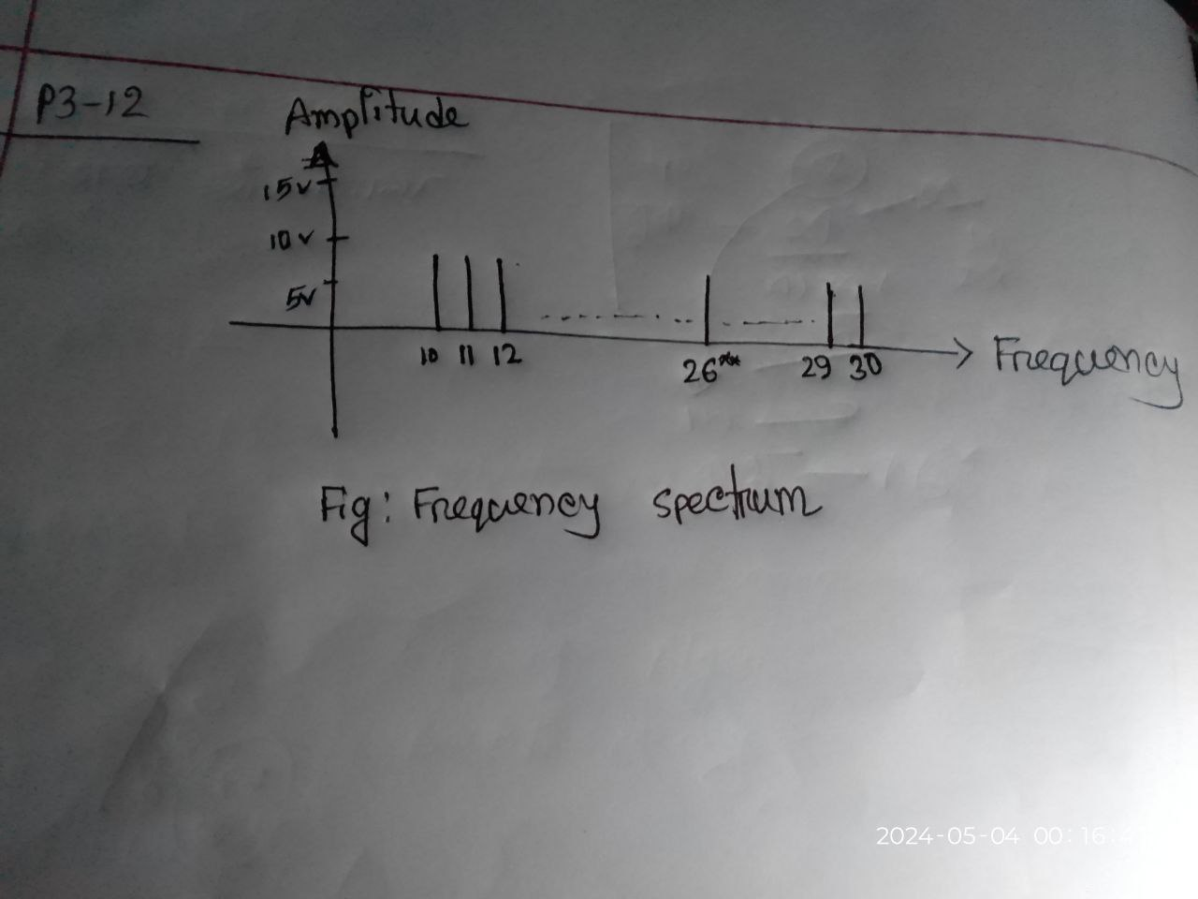

**P3-13.** A nonperiodic composite signal contains frequencies from 10 to 30 KHz. The peak amplitude is 10 V for the lowest and the highest signals and is 30 V for

the 20-KHz signal. Assuming that the amplitudes change gradually from the

minimum to the maximum, draw the frequency spectrum.

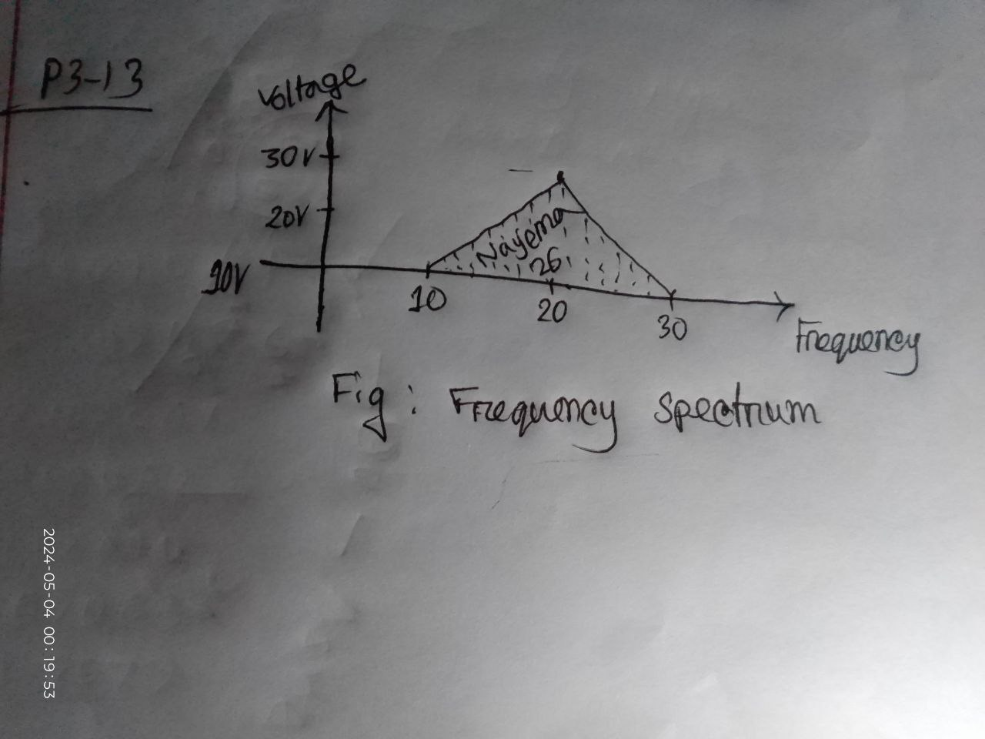

**P3-14.** A TV channel has a bandwidth of 6 MHz. If we send a digital signal using one channel, what are the data rates if we use one harmonic, three harmonics, and

five harmonics?

Answer:

One harmonic means two waves (in positive half and negative half)

So one harmonic means 2*6=12Mbps

Three harmonic means 6*6=36 Mbps

Five harmonic means 10*6=60Mbps.

**P3-15.** A signal travels from point A to point B. At point A, the signal power is 100 W. At point B, the power is 90 W. What is the attenuation in decibels?

Answer:

Attenuation (dB)=10×log10​(*P*out/​*P*in​​)

= 10 x log10 (90/10)

=0.45dB

**P3-16.** The attenuation of a signal is −10 dB. What is the final signal power if it was originally 5 W?

Answer:

Attenuation= $10\log_{10}{\frac{p}{5}}$ dB= -10

=0.5 W

**P3-17.** A signal has passed through three cascaded amplifiers, each with a 4 dB gain. What is the total gain? How much is the signal amplified?

Answer:

I don’t know what’s the solution is that…… :)

**P3-18.** If the bandwidth of the channel is 5 Kbps, how long does it take to send a frame of 100,000 bits out of this device?

Answer:

Transmission time = 100,000 / (5 x 1000) = 20sec

**P3-19.** The light of the sun takes approximately eight minutes to reach the earth. What is the distance between the sun and the earth?

Answer:

Distance=Speed ×Time

= (3×108 m/s)× 8 x 60 s = 1.44×1011 meters

**P3-20.** A signal has a wavelength of 1 μm in air. How far can the front of the wave travel during 1000 periods?

Answer:

Total distance=Distance per period ×Number of periods

Total distance=1 𝜇𝑚×1000Total distance=1*μm*×1000

Total distance=1000 𝜇𝑚Total distance=1000*μm*

**P3-21.** A line has a signal-to-noise ratio of 1000 and a bandwidth of 4000 KHz. What is the maximum data rate supported by this line?

Answer:

Capacity=B*log2(1+SNR)

=4000 x 10^1000 *log2(1+ 1000)= 39868.90504 Kbps

**P3-22.** We measure the performance of a telephone line (4 KHz of bandwidth). When the signal is 10 V, the noise is 5 mV. What is the maximum data rate supported by this telephone line?

Answer: Using Shannon theorem,

Capacity=B*log2(1+SNR)

=4000 *log2(1+ 10/5*10^3)=11.53bps

**P3-23.** A file contains 2 million bytes. How long does it take to download this file using a 56-Kbps channel? 1-Mbps channel?

Answer:

File size=2 million bytes=2000000*8 bits=16000000 bits

For 56-Kbps, Channel speed b=56000bps

Time=16000000 /56000=285.714 s

For 1-Mbps, Channel speed b=1000000bps

Time=16000000 /1000000=16s

**P3-24.** A computer monitor has a resolution of 1200 by 1000 pixels. If each pixel uses 1024 colors, how many bits are needed to send the complete contents of a screen?

Answer:

Bits needed=1200*1000*1024=1.22888 ${10}^{9}$* bits

**P3-25.** A signal with 200 milliwatts power passes through 10 devices, each with an average noise of 2 microwatts. What is the SNR? What is the SNRdB?

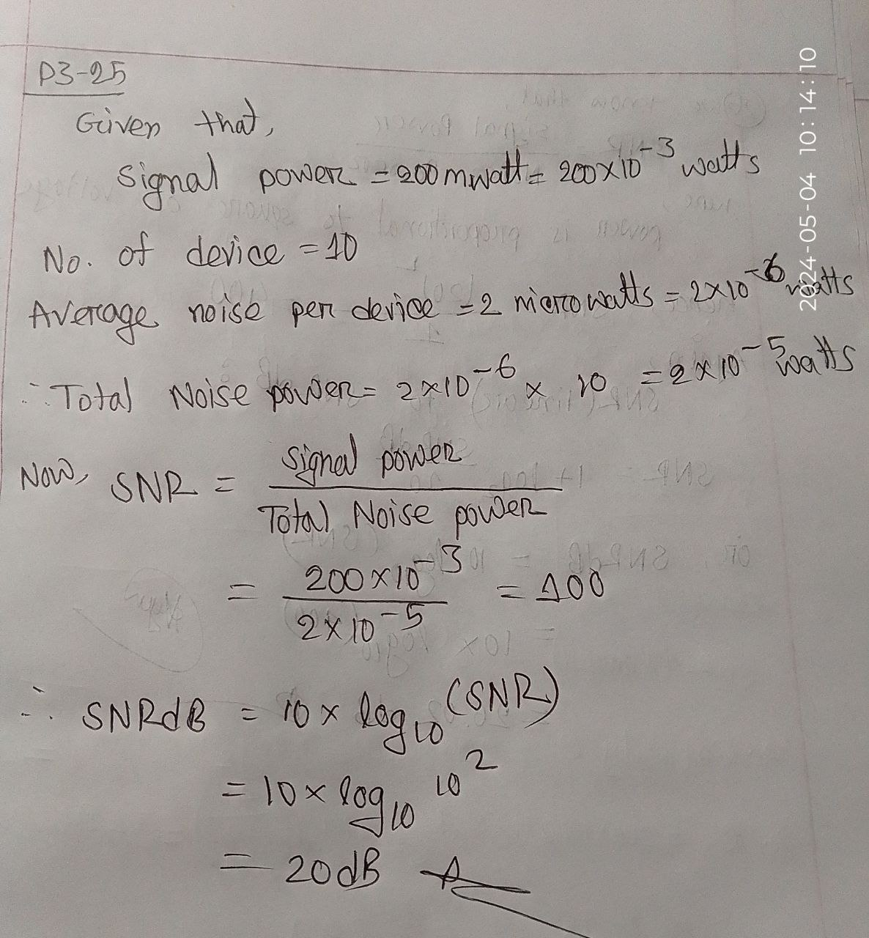

**P3-26.** If the peak voltage value of a signal is 20 times the peak voltage value of the noise, what is the SNR? What is the SNRdB?

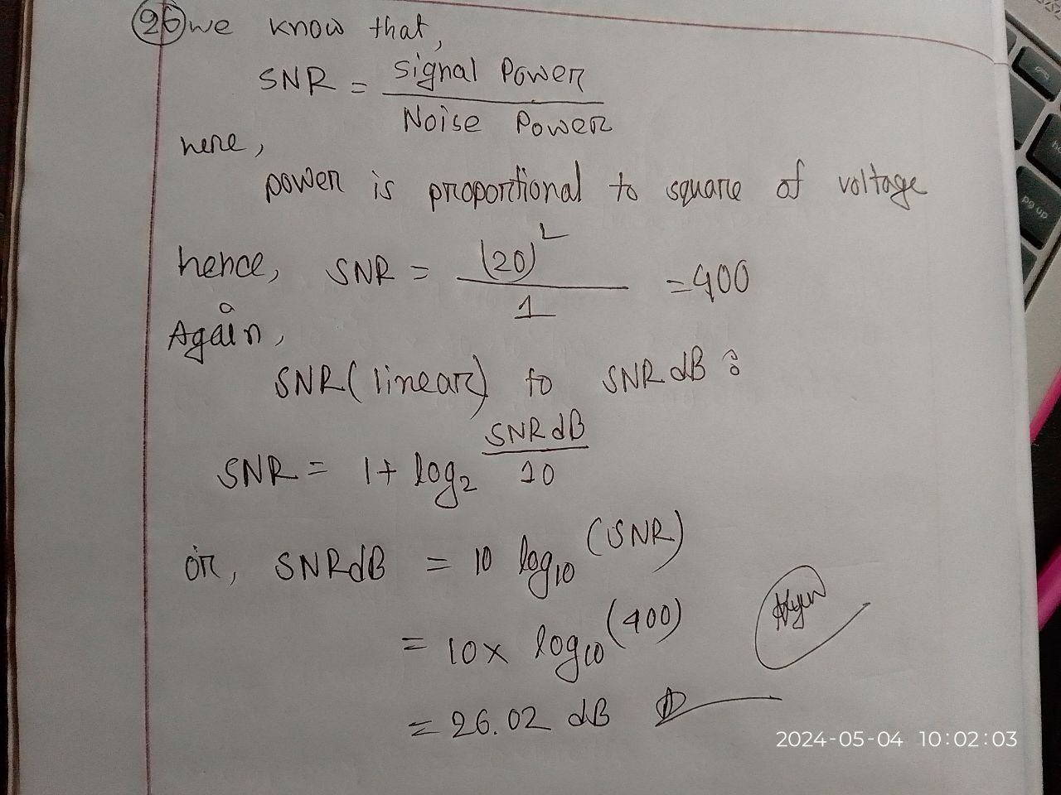

**P3-27.** What is the theoretical capacity of a channel in each of the following cases? **a.** Bandwidth: 20 KHz SNRdB = 40

**b.** Bandwidth: 200 KHz SNRdB = 4

**c.** Bandwidth: 1 MHz SNRdB = 20

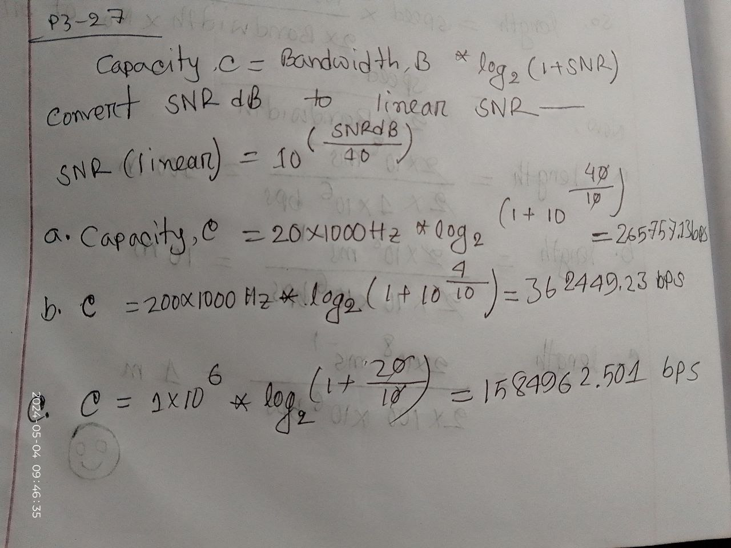

**P3-28.** We need to upgrade a channel to a higher bandwidth. Answer the following questions:

**a.** How is the rate improved if we double the bandwidth?

**b.** How is the rate improved if we double the SNR?

Answer:

1. According to the Nyquist theorem, if we double the bandwidth, the data rate is also doubled.
2. According to the Shannon theorem, if we double the SNR, the data rate increases proportionally to the logarithm of 2, which is approximately 0.3.

**P3-29.** We have a channel with 4 KHz bandwidth. If we want to send data at 100 Kbps, what is the minimum SNRdB? What is the SNR?

Answer:

SNR (linear) = 10^((C / B) - 1)

where:

C = Data rate (bps) = 100000 bps

B = Bandwidth = 4000 Hz

Now,

SNR (linear) = 10^((100000 / 4000) - 1) ≈ 15.85

Minimum SNR(dB):

SNR(dB) = 10 * log10 (SNR) = 10 * log10 (15.85) ≈ 12.01 dB

**P3-30.** What is the transmission time of a packet sent by a station if the length of the packet is 1 million bytes and the bandwidth of the channel is 200 Kbps?

Answer:

Transmission time = massage size / Bandwidth

= ( 1 x 10^6 * 8 bits) / (200 * 10^3 bps)

= 40 seconds.

**P3-31.** What is the length of a bit in a channel with a propagation speed of 2 ⋅ 108 m/s if the channel bandwidth is **a.** 1 Mbps? **b.** 10 Mbps? **c.** 100 Mbps? ­­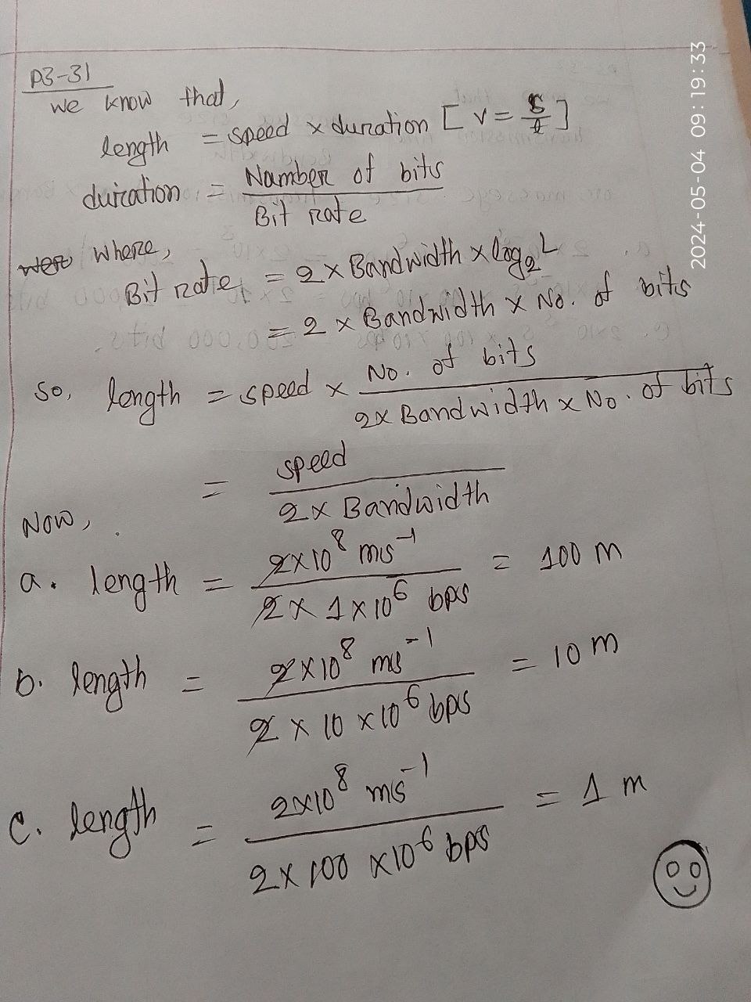

**P3-32.** How many bits can fit on a link with a 2 ms delay if the bandwidth of the link is

1. 1 Mbps? **b.** 10 Mbps? **c.** 100 Mbps? 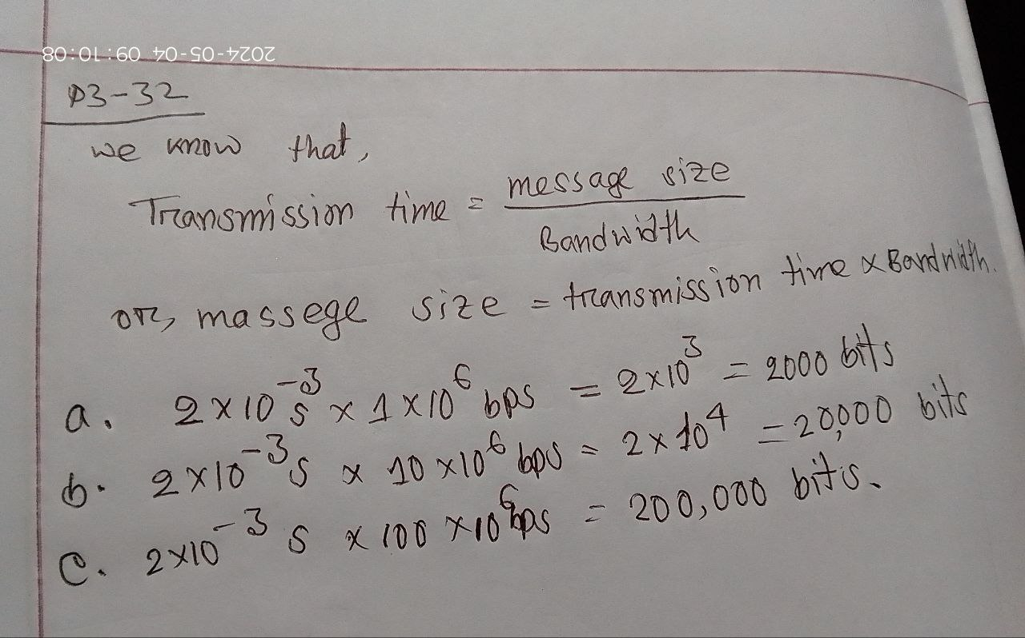

**P3-33.** What is the total delay (latency) for a frame of size 5 million bits that is being sent on a link with 10 routers each having a queuing time of 2 μs and a pro

cessing time of 1 μs. The length of the link is 2000 Km. The speed of light

inside the link is 2 ⋅ 108 m/s. The link has a bandwidth of 5 Mbps. Which

component of the total delay is dominant? Which one is negligible? 